**Attention and Listening**

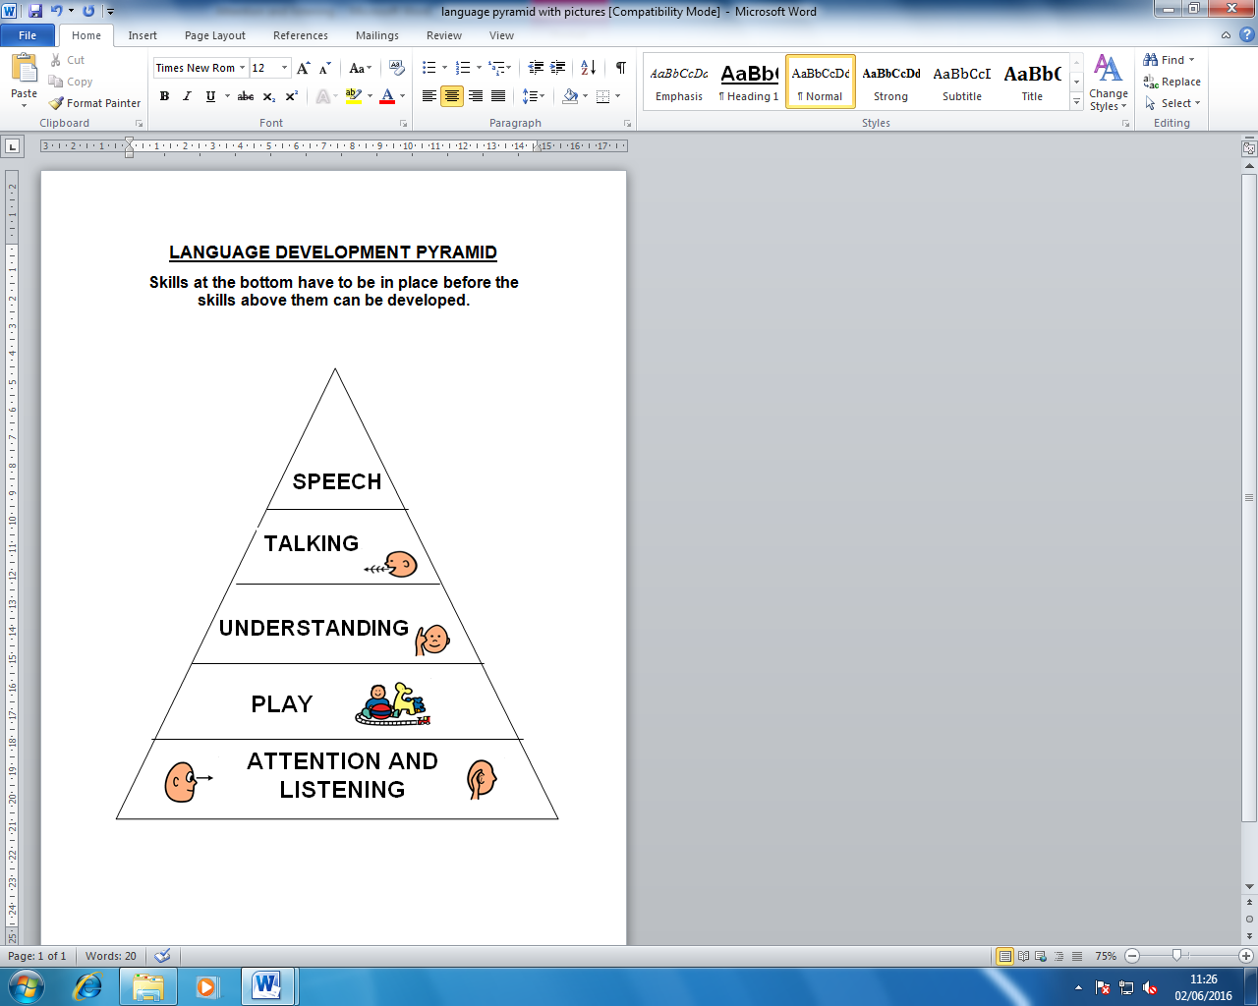

The Communication Pyramid shows the different elements that make up speech, language and communication.

Children need to listen, attend and process what they hear around them so they can learn and understand new words.

* **Time to talk** 🡪 Turn off electronic devices (e.g. tablets, phones, TV) and reduce other distractions when talking to and playing with your child.
* **Use their name** 🡪 Get your child’s attention by using their name, before talking to them and giving them instructions.
* **Get down to their level** 🡪 Face your child when you’re talking and playing with them.
* **Give specific praise** 🡪 e.g. “Good looking”, “good sitting” instead of “well done” and “good boy”.
* **Use visuals** 🡪 to support your child to focus for longer, for example:

|  |  |  |
| --- | --- | --- |
| Sand timers | ‘Now and next’ board | Behaviour prompt cards |
| http://www.cheapdisabilityaids.co.uk/ekmps/shops/podcmedia/images/special-needs-sand-timer-1-minute-3526-p.jpg | NOW NEXT |  |

* **Use rewards** 🡪as a way to motivate your child to complete activities.

E.g. “First homework, next play.” Use reward charts which include your child’s interests to earn stickers/play time.

* **Take turns 🡪** Play turn-taking games with your child to develop their sharing and waiting skills. Make it clear whose turn it is; say “my turn”, “your turn”. E.g. take turns to build a tower, pass a ball, etc.

Useful websites: [www.ican.org.uk](http://www.ican.org.uk) and [www.talkingpoint.org.uk](http://www.talkingpoint.org.uk)

Visit our website at [www.cnwl.nhs.uk/hillingdon-talks](http://www.cnwl.nhs.uk/hillingdon-talks) for more information and links to further useful websites

 Find us on Facebook at ‘Hillingdon Paediatric Speech and Language Therapy’ for more handy hints and tips