**Social Communication**

The Communication Pyramid shows the different elements that make up speech, language and communication.

Social communication includes:

* The way we use language to communicate with

others

* Making and maintaining friends
* Understanding emotions
* Understanding and using facial expressions and body language
* Taking turns in games and conversations
* Knowing how to respond to different social situations

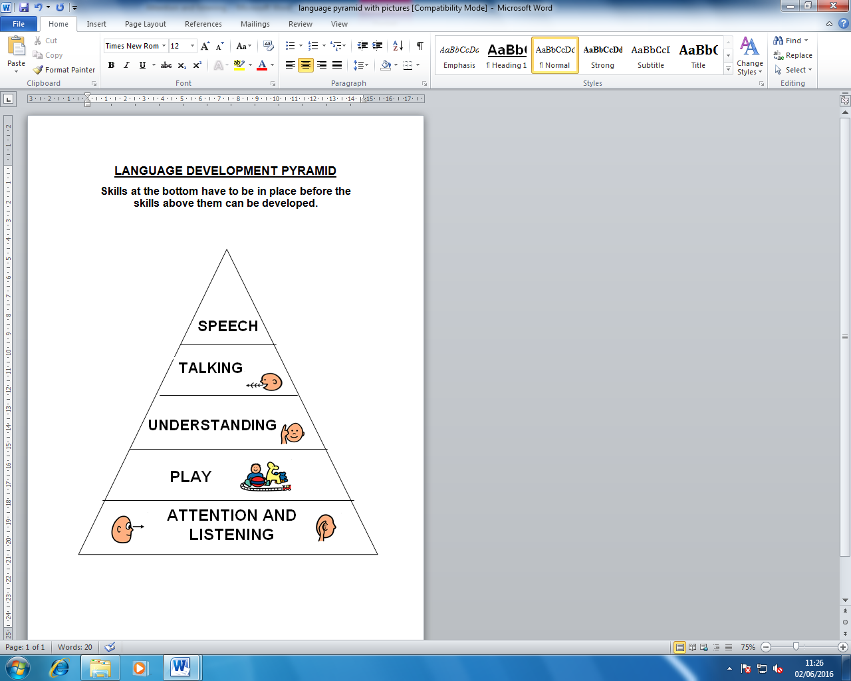

* **Create opportunities for communication 🡪** Your child may need help to understand how and why we communicate. Offer your child choices and encourage them to request, to show them the benefits of communicating.
  + E.g. Ask your child “water or juice?” and wait for them to make a choice.
  + Put a favourite toy out of reach so they have to ask you for the toy.
  + Pause during fun activities and wait for your child to show you that they want more. They may show this by saying ‘more’, pointing or reaching, or looking at you.
* **Provide structure 🡪** Your child may find it difficult to manage moving between activities and changes in their routine. Visual supports can help to prepare your child for changes and to build structure into their day. Here are some examples you could try:

|  |  |  |  |
| --- | --- | --- | --- |
| Visual timetable  [Visual Timetable for,](http://4.bp.blogspot.com/_p92h-zwz-yc/S0LNXQiuCzI/AAAAAAAACaQ/8bprWACGqaU/s400/Schedule+powerpoint+fixed.jpg) | Use a ‘Now and next’ board    NOW NEXT | Use sand timers to show your child how long they have before the activity finishes.  http://www.cheapdisabilityaids.co.uk/ekmps/shops/podcmedia/images/special-needs-sand-timer-1-minute-3526-p.jpg | Checklists, e.g. getting ready for bed, dressing for school.  [Visual schedule for dressing](http://yikestikes.com/wp-content/uploads/images/dressing-visual-checklist.jpg) |

* **Use rewards 🡪** If your child needs extra encouragement to complete activities which have been chosen by an adult, use rewards as a way to motivate them to complete these activities/tasks. E.g. 5 ticks on their chart and then a reward of your child’s choice (Lego, dinosaur stickers).
* **Use positive language 🡪** to reinforce good behaviour and provide specific praise. E.g. “That’s good sharing with your brother” and “Kind hands” instead of “No hitting.”
* **Make it visual 🡪** Spoken language is easier to understand when there is visual support. Gesture, objects, pictures and/or symbols can be used alongside talking. E.g. Show them their coat when you’re going out. Use hand gesture along with spoken instruction to “Sit down.”
* **Be direct 🡪** Use your child’s name to get their attention and use key words when giving instructions. E.g. “Jack coat on” instead of “Jack please can you go & get your coat & put it on?”
* **Say what you mean 🡪** Your child may understand language literally. Try to keep your language clear and simple. E.g. If you tell your child that you’ll be leaving in ‘1 minute’ they may expect to leave within that time. Avoid using idioms, e.g. “Pull your socks up”, “It’s raining cats and dogs”
* **Explain emotions** 🡪 To develop your child’s understanding of different emotions, talk about how your child and others feel in different situations, and discuss reasons why. E.g. “Sarah is feeling excited today because it’s her birthday; she is smiling.” Explain how your facial expressions and body language may change when feeling different emotions.
* **Help your child to develop their play skills 🡪** Show your child how to play with a variety of toys in different ways to help them develop their imagination. Encourage your child to play and take turns with others. E.g. Feed teddy at a tea party, play with a farmyard set, take turns to pass a ball. Pretend that a brick is a phone, a car, or a cake.
* **Practise conversation skills 🡪** Your child may have difficulties starting, maintaining, and finishing conversations. Support your child to have conversations about different topics. Practise taking turns, asking questions, and listening. E.g. Share news about your day and ask each other questions. Provide your child with specific praise on what they did well, e.g. ‘that was a good question.’

Useful website: [www.autism.org.uk](http://www.autism.org.uk) (Please note these strategies are useful for children with social communication needs as well as those with Autism).

Visit our website at [www.cnwl.nhs.uk/hillingdon-talks](http://www.cnwl.nhs.uk/hillingdon-talks) for more information and links to further useful websites

 Find us on Facebook at ‘Hillingdon Paediatric Speech and Language Therapy’ for more handy hints and tips