New LADO process in Hillingdon
The purpose of this document is to introduce the Hillingdon Lado service and to update you about some of the changes in our service and the more streamlined way in which you can contact the LADO.
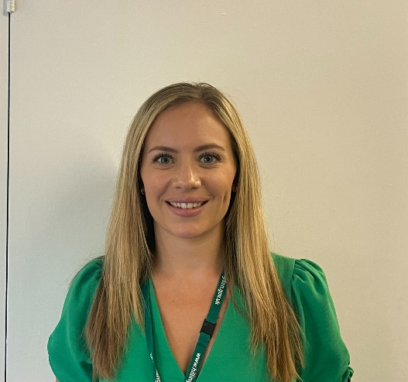
Local Authority Designated Officer for Hillingdon:
Hannah Ives

NEW LADO Contact Form
To ensure that your contact is dealt with in the most effective way we have introduced an electronic contact form. This form should be used both to make a referral to the LADO but also to seek advice and guidance. The LADO contact form is available here.
Please note that to ensure we are reviewing your contacts in a timely manner and providing you with the best advice the LADO will no longer be able to discuss new concerns without a contact form being submitted in advance.
Hillingdon LADO process:
The LADO must be contacted within one working day in respect of all cases in which it is alleged that a person who works or volunteers with children has (in connection with their employment, voluntary role or in their personal life):
- behaved in a way that has harmed, or may have harmed a child;
- possibly committed a criminal offence against or related to a child; or
- behaved towards a child or children in a way that indicates they may pose a risk of harm to children.
- Behaved or may have behaved in a way that indicates they may not be suitable to work with children
This includes all paid, unpaid, volunteers, casual, agency or anyone self-employed who works with children including foster carers and prospective adopters, as well as 16 & 17 year olds placed in a position of trust.
Each organisation working with children should have a designated lead manager who is responsible for reporting any allegation meeting the above criteria to the LADO. If the concern has been reported directly to police or Local Authority’s Social Care, they should report the matter to the LADO.
Initially it may be unclear how serious an allegation is and if it meets the above criteria. If there is any doubt advice from the LADO must be sought. In both these scenarios a contact form should be submitted to the LADO within one working day.
Any further advice or guidance needed from the LADO, for example to discuss a low-level concern or staff conduct matters, must also be requested via the LADO contact form. This new process allows the LADO time to review information and ensures a clear record of concerns is kept, ensuring past concerns are reviewed as part of any decision.
The LADO will prioritise any matters considered high risk and will endeavour to respond to these in 24 hours, and all other contacts within 48 hours. Once the contact form has been received, the LADO will make contact with the referrer to discuss next steps or arrange a suitable time for a further discussion or meeting. Following discussion with the LADO, if the criteria is not felt to be met, then rationale for no further action from the LADO will be recorded and shared with the referrer.
Please remember:
If you are making a referral about an individual you must make them aware you are doing this as a record will be kept. The only exception is if you feel a crime has been committed and the adult is unaware of the concern or allegation, in these cases please note this on the contact form and the LADO can provide advice around when the individual should be informed.
What will the LADO do next?
- Help establish what the 'next steps' should be in terms of investigating the matter further
- Provide advice and guidance regarding matters where threshold is not met
- Coordinate the safeguarding and investigative process in response to allegations that do meet threshold
- Liaise with the police and other agencies, and arrange for a LADO Allegations (ASV) meeting to be held if required; if the case is complex there may be a series of meetings
- Monitor and maintain an overview of cases to ensure they're dealt with as quickly as possible, consistent with a thorough and fair process
- Provide advice in relation to the accused person remaining in post over the course of the investigation
- Ensure appropriate sharing of information with parents, children, the accused and other relevant individuals is considered, as well as their support needs
- Support to ensure a suitable evidence-based outcome is reached
- Assist employers in decisions about a person's suitability to remain in the children's workforce, and whether a referral should be made to the Disclosure and Barring Service (DBS) or the appropriate regulatory or professional body
- Consider any organisational learning
*Please note that the LADO does not conduct investigations themselves but instead has oversight of any investigative process. The overall responsibility will remain with the employer.
Local Authority Designated Officer for Hillingdon:
Hannah Ives
Deputy LADO (& Child Protection Lead for Education):
Nicole Diamond

Tel: 01895 250975
Email: lado@hillingdon.gov.uk

